**M3 DEV/TST Grid Access**

* [https://infkcappdt9.pork.seaboard.local:22108/grid/ui/#](https://infkcappdt9.pork.seaboard.local:22108/grid/ui/) - DEV Grid
* [https://infkcappdt9.pork.seaboard.local:21108/grid/ui/#](https://infkcappdt9.pork.seaboard.local:21108/grid/ui/) - TST Grid
* <https://infkcappdt9.pork.seaboard.local:22108/grid/ui/#/MECDEV> - DEV MEC
* <https://infkcappdt9.pork.seaboard.local:21108/grid/ui/#/MECTST> - TST MEC

**Installing Eclipse and MEC Tools**

1. Install Java SDK 1.7 to local PC
   1. **Go to this folder: \\infkcapplcm\software$\zOther Software\Java**
   2. **Double Click on highlighted .exe**

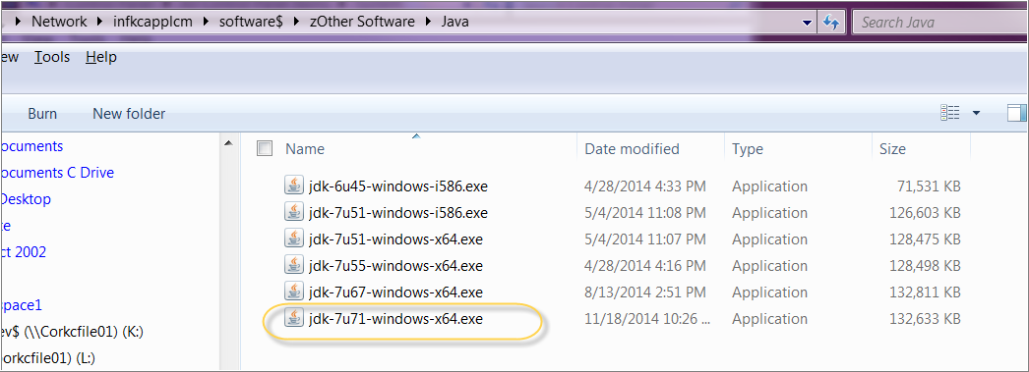

* 1. **When you get to the screen below, click on ‘Change’ and follow the screens**

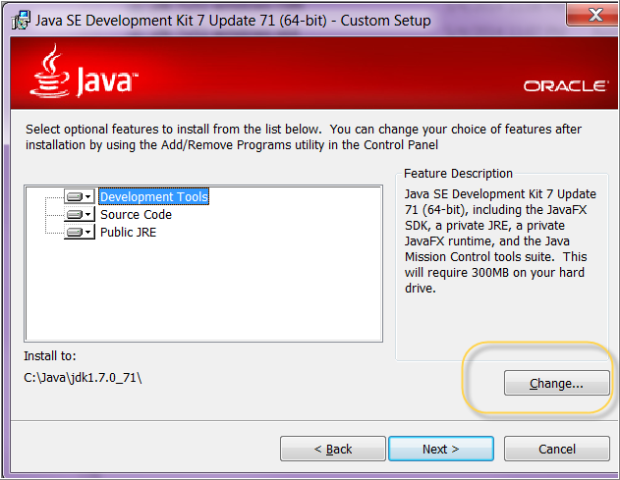

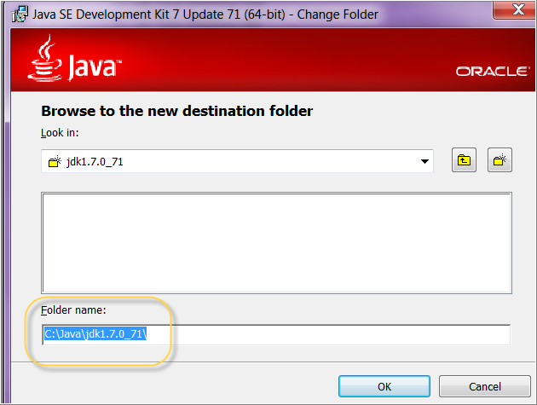

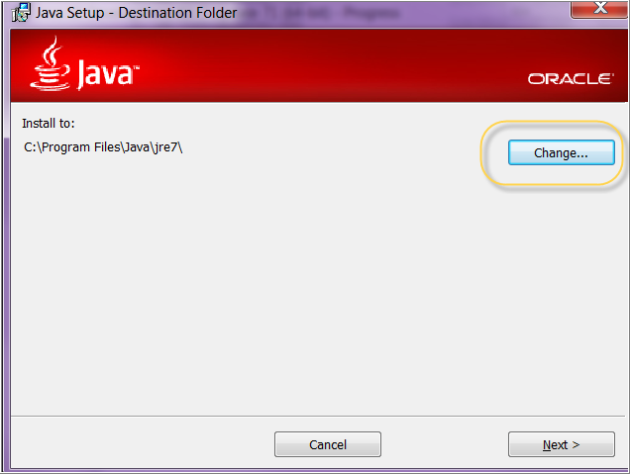

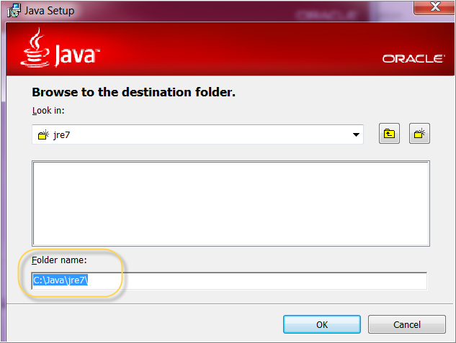

1. Copy Infor Software from the software folder to your desktop.
   1. **Create a folder on your desktop called ‘MECDeveloperTools’**
   2. **Go to the path in Windows Explorer:** \\infkcapplcm\software$\MEC Developer Tools
   3. **Copy the entire content of the ‘MEC Developer Tools’ folder and paste it into your Desktop folder ‘MECDeveloperTools’**

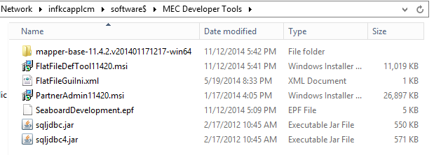

1. Create JAVA_HOME & MEC_CLASSPATH Environment Variable
   1. **Control Panel > System > Advanced system settings > Environment Variables**
   2. **Click ‘New’ for System variables.** 
      1. **Create JAVA_HOME Environment Variable (Path to Java SDK Folder).**
         1. **C:\Program Files\Java\jdk1.7.0_71**
      2. **Create MEC_CLASSPATH Environment Variable (Path to sqljdbc4.jar).** 
         1. **C:\Users\pdroge\Desktop\INFOR\MECDevelopersTool\sqljdbc4.jar**

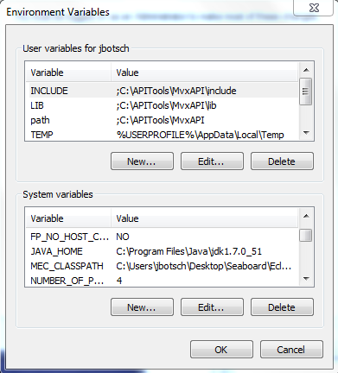

1. Open ecplise.exe or mapper.exe **(from the newly created folder on your Desktop)**

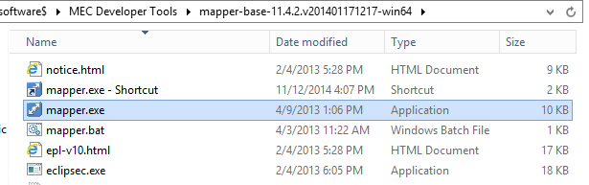

* 1. **Create the Workspace on your desktop into \Infor\MECTools\Workspace**
  2. **Import Preferences (SeaboardDevelopment.epf – contains local DEV/TST settings)**
     1. **Click File > Import > General > Preferences**

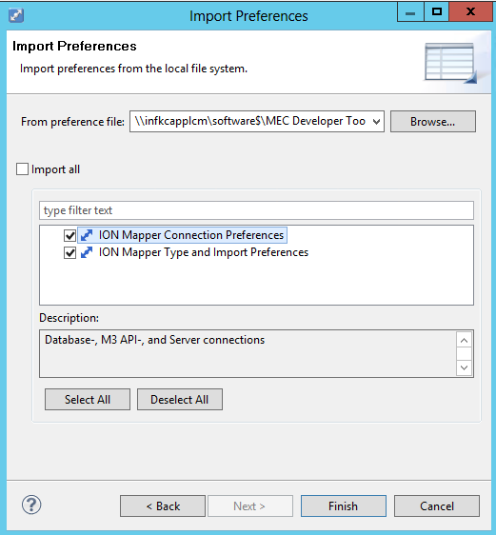

1. Install PartnerAdmin11420.msi (Requires MEC_CLASSPATH)



1. Install FlatFileDefTool11420.msi



1. Replace FlatFileGuiIni.xml in your local folder with the file from ‘MECDeveloperTools’ folder on your desktop. (Contains local DEV/TST settings)



1. **Local Folder: C:\Program Files (x86)\MEC 11.4.2\Flat File Definition Tool**

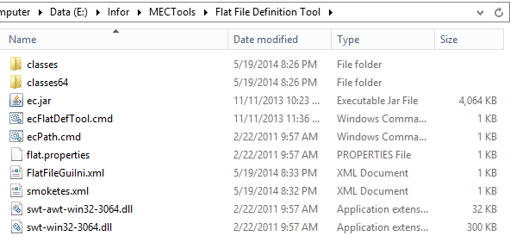

1. Copy file PADMINI.XML from your desktop folder to your local folder



* 1. **Local Folder: C:\Program Files (x86)\MEC 11.4.2\Flat File Definition Tool**